## 5.UML DIAGRAMS FOR ONLINE SHOPPING SYSTEM

## GOWARAPPAGARI GANESH

## {192011088}

## AIM:

To draw UML diagram for Online voting system using Umbrello tool.

## PROBLEM STATEMENT:

**Online shopping system:**

In day to day life, we will need to buy lots of goods or products from a shop. It may be food items, electronic items, house hold items etc etc. Now a days, it is really hard to get some time to go out and get them by ourselves due to busy life style or lots of works. In order to solve this, B2C E-Commerce websites have been started. Using these websites, we can buy goods or products online just by visiting the website and ordering the item online by making payments online. This existing system of buying goods has several disadvantages. It requires lots of time to travel to the particular shop to buy the goods. Since everyone is leading busy life now a days, time means a lot to everyone. Also there are expenses for travelling from house to shop. More over the shop from where we would like to buy something may not be open 24*7*365. Hence we have to adjust our time with the shopkeeper’s time or vendor’s time. In order to overcome these, we have e-commerce solution, i.e. one place where we can get all required goods/products online. The proposed system helps in building a website to buy, sell products or goods online using internet connection. Purchasing of goods online, user can choose different products based on categories , online payments , delivery services and hence covering the disadvantages of the existing system and making the buying easier and helping the vendors to reach wider market.draw a use case diagram for given scenario.

**Login/Register:**

* The user is a visitor, who visits the site and buy something from our website by making an online payment (or) otherwise he can register.
* Both customer and admin have different task in online system.

**Admin**:

Admin is a responsible person to run the whole system.Admin can add delete, update all information, order information, item information.

**Admin scenarios:**

* Login module
* Manage items
* Process a order
* Cancel the order
* Process return
* Online help

**Customer scenarios:**

* Registration for new customer
* Login for existing customers
* Place a order
* Browser the item
* Change the password
* Cancel the order
* Make payment

**Courier service scenarios are:**

* The courier service has to provide by the deliver the orders to the customers.
* And also return items for the customer’s ad send to the back to sales marketing.

**Payment:**

The customer choose the payment option when he was placed a order.The payment is handled by the bank and the payment which could be done either by using credit card and debit card or cash on delivery.

**Online help:**

When the customers are needs a help the system will provide the online help system.

**USECASE DIAGRAM:**

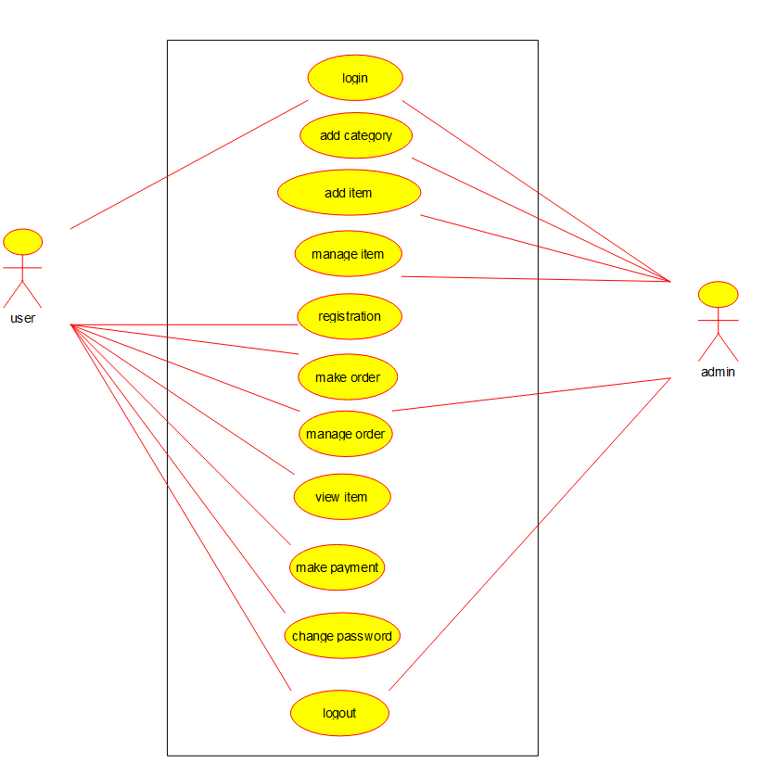

**CLASS DIAGRAM:**

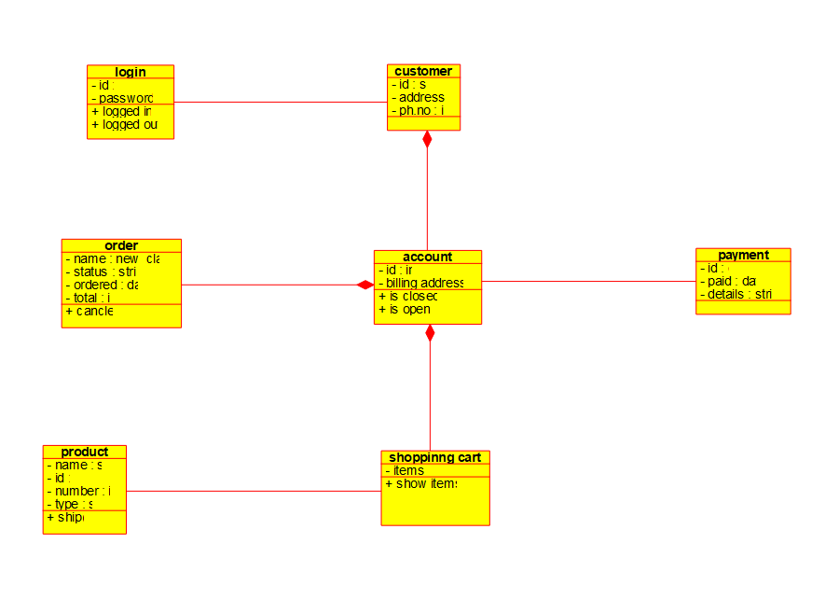**SEQUENCE DIAGRAM:**

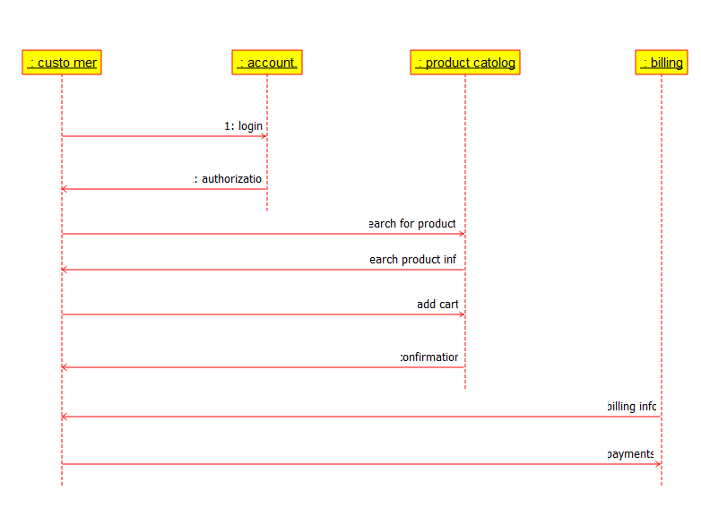

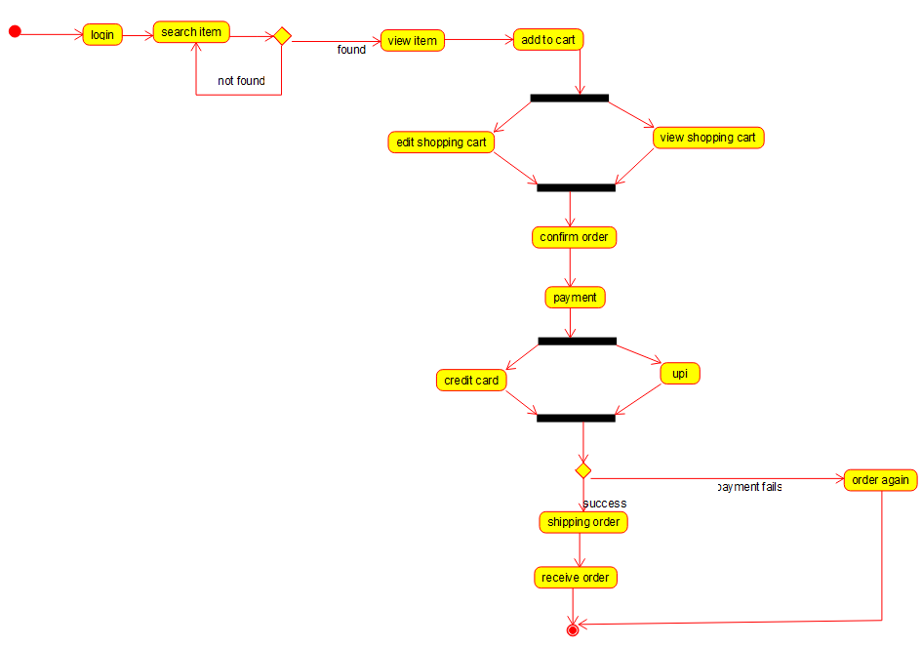**ACTIVITY DIAGRAM:**

**RESULT:**

Thus, the use-case diagram for online shopping system is drawn and verified successfully.